Written By: Unknown
Copyright Unknown1
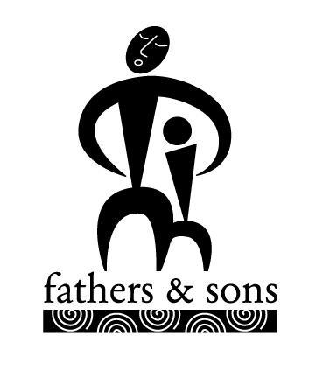
Father Abraham had many sons
Many sons had Father Abraham
I am one of them and so are you
So let's all praise the Lord.
Right arm!
Father Abraham had many sons
Many sons had Father Abraham
I am one of them and so are you
So let's all praise the Lord.
Right arm, left arm!
Father Abraham had many sons
Many sons had Father Abraham
I am one of them and so are you
So let's all praise the Lord.
Right arm, left arm, right foot!
Father Abraham had many sons
Many sons had Father Abraham
I am one of them and so are you
So let's all praise the Lord.
Right arm, left arm, right foot, left foot!
Father Abraham had many sons
Many sons had Father Abraham
I am one of them and so are you
So let's all praise the Lord.
Right arm, left arm, right foot, left foot,
Chin up!
Father Abraham had many sons
Many sons had Father Abraham
I am one of them and so are you
So let's all praise the Lord.
Right arm, left arm, right foot, left foot,
Chin up, turn around!
Father Abraham had many sons
Many sons had Father Abraham
I am one of them and so are you
So let's all praise the Lord.
Right arm, left arm, right foot, left foot,
Chin up, turn around, sit down!
Actions
Right arm: Clench fist, bend and extend arm upward repeatedly throughout song
Left arm: Add left arm in same motion as right
Right foot: Add right foot stepping up and down
Left foot: Add left foot stepping up and down
Chin up: Add head nodding up and down
Turn around: Add turning in place while continuing other motions
Sit down: Sit down :-)

