SANKOFA
(Return and Fetch It)
”SE wo werE fi na wosankofa a yenkyi”

It is no taboo to return and fetch it when you forget. You can always undo your mistakes.

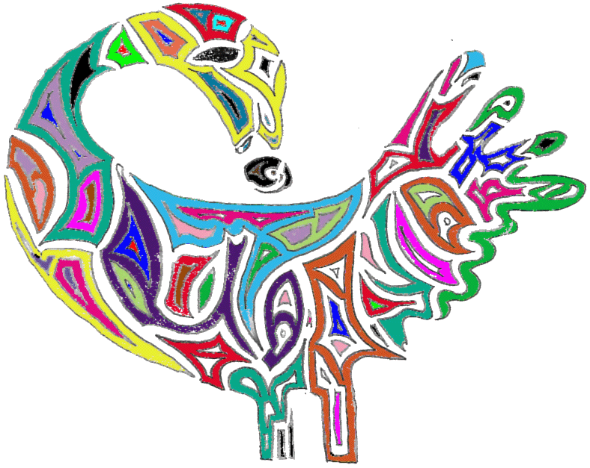

Please visit the Adinkra Symbolism Website (http://quattro.me.uiuc.edu/~fog/adinkra.html) in case you would like to see other symbols for us in the cohort naming activity.

