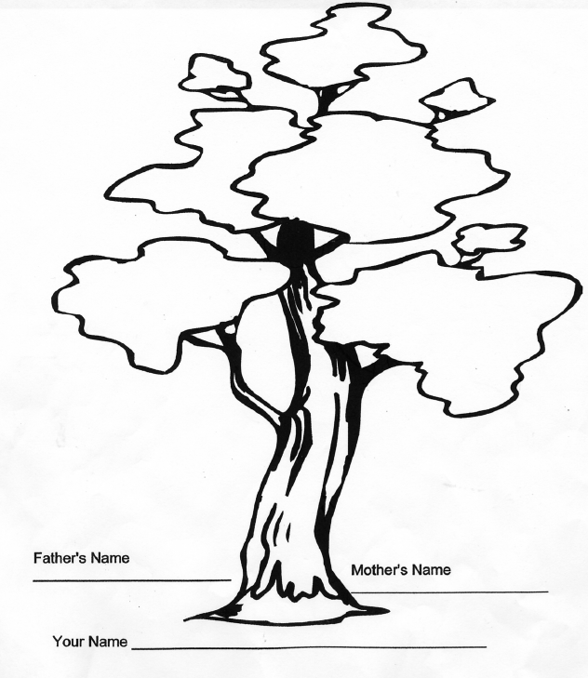
Family Tree

Description: The family tree activity is designed to allow sons identify family members and to engage them in a discussion about their family members.

Instructions: Starting at the bottom of the tree, have the son(s) write their names at the trunk of the tree. Near the bottom of the tree trunk, sons should add their parents’ names. The tree “branches out” into different clusters of leaves where the sons and fathers are to identify sisters, brothers, and other significant family members along their lineage. Have the participants write the names of the relevant family members and engage them in a discussion about these individuals in their lives.

