Introduction to African Drum and Dance

“A village without music is a dead village.” – African Proverb

- The drum is one of the most ancient African instruments, dating back tens of thousands of years.

- It has been used for healing, celebration, ritual, worship, rites of passage, divination, communicating tribe to tribe, and with the earth and spirit realms.
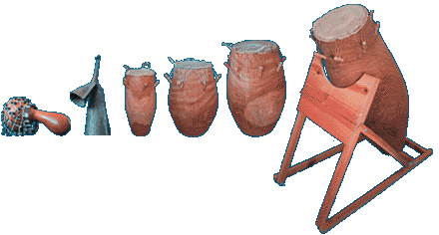

- The most popular drums are the Afro-Cuban Conga and the West African Djembe.
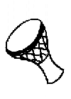-Djembes
- African tradition includes an Aural (hearing) and an oral (speaking) tradition. Drumming and dance are expressed in an improvisational fashion.
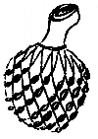-Shakere

“Where people gather to drum, they usually dance. When the body feels the pulse, it becomes eager to speak through the beat.”

- Throughout history people have expressed themselves and their understanding of the world through the arts.

- We can use artistic expression to communicate with one another.

- Dance and drumming, for example, are languages through which we express our fears and anxieties, our curiosities and hungers, our discoveries and hopes.
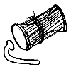
-Talking Drums

- Dance and drumming enable us to express our need for understanding, love, order, beauty, safety, relief, and longevity.

- Dance and drumming are the imprints we make that tell us and others who we are; that we belong to something special, and that we are important.
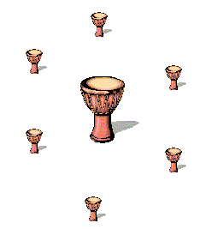

The Importance of RHYTHM in African culture
- To evoke creative expression among African Americans through dance and drumming (also spoken word).
- Drumming helps us to find the creative part of ourselves.
- Creative expression leads to positive expression of self, which makes us feel good about ourselves.
- Creative expression encourages a stronger connection (more positive association) with other people dancing and drumming with us.
- According to Olatunji, we “become one spirit through rhythm”. The result can be a sense of community among people who thought they had nothing in common.

The same hand that boys and girls
use to shoot each other, they can use to DRUM!

“Where I come from we say that rhythm is the soul of life, because the whole universe revolves around rhythm…with the drum you can find yourself…you can learn how to heal yourself.”
– Baba Olatunji – African Percussionist

